Failed Test Case Report – AI Model Requirement Validation
Test Case ID | AI_REQ_004
Test Case Title: Verify AI ranking endpoint behavior when processing a valid ranking request.
Module: AI Study Plan – Student Ranking API
Priority: High
Severity: Medium
Status: Failed

Objective
To verify that the AI service successfully processes a valid student ranking request and returns the generated ranking and personalized study plan.

Preconditions
- AI service is running successfully.
- FastAPI server is accessible.
- Swagger UI is available.
- PostgreSQL database connection is required for retrieving student and question data.

Test Data
Parameter | Value
Student ID | test123
Exam Type | JEE

Test Steps
Step | Action
1 | Launch the AI service using Uvicorn.
2 | Open Swagger UI (http://127.0.0.1:9000/docs).
3 | Open the endpoint GET /{student_id}/{exam_type}.
4 | Enter student_id = test123.
5 | Enter exam_type = JEE.
6 | Click Execute.

Expected Result
The application should:
- Validate the request successfully.
- Retrieve the student test history from the database.
- Generate the topic ranking.
- Generate daily, weekly, and monthly study plans.
- Return HTTP 200 OK with the AI-generated response.
If the database is unavailable, the application should return a controlled error response (for example, HTTP 503 Service Unavailable or a descriptive JSON error message).

Actual Result
The application returned:
HTTP Status
500 Internal Server Error
Response Body
Internal Server Error
No descriptive error message was returned to indicate that the database configuration was unavailable.

Root Cause
The AI service depends on a PostgreSQL database connection. During startup, the application reported:
DATABASE_URL is not set.
When the ranking endpoint was invoked, the missing database connection caused an unhandled exception, resulting in a generic HTTP 500 response.

Impact
- Student ranking cannot be generated.
- Personalized study plans cannot be generated.
- AI recommendation functionality becomes unavailable.
- Users receive a generic server error without information about the underlying issue.

Recommendation
- Validate the database configuration during application startup.
- Catch database connection exceptions before processing requests.
- Return a structured error response instead of a generic HTTP 500 response.
Example:
{
"error": "Database connection is not configured.",
"status": 503
}
or
{
"message": "AI service is temporarily unavailable. Please try again later."
}

Evidence
Endpoint Tested
GET /test123/JEE
Observed Response
- HTTP Status: 500 Internal Server Error
- Response Body: Internal Server Error

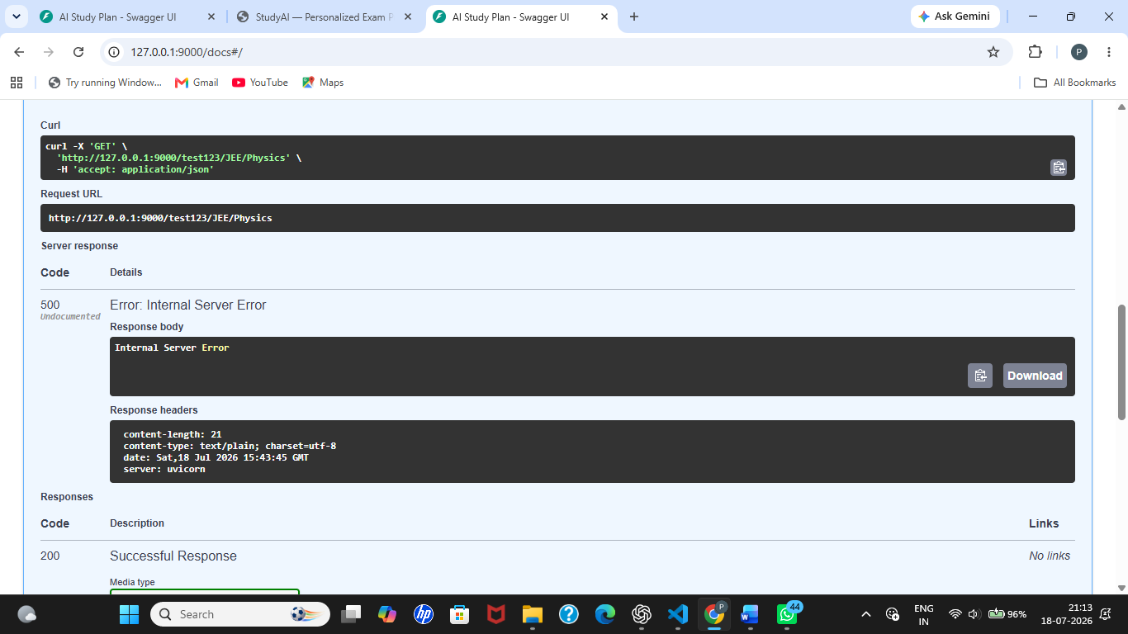
Failed Test Case Summary
Test Case ID | Test Case | Expected Result | Actual Result | Status
AI_REQ_004 | Verify valid student ranking request | AI service should return HTTP 200 with ranking and study plan, or a controlled service-unavailable error if the database is inaccessible | Application returned HTTP 500 Internal Server Error due to missing PostgreSQL configuration (DATABASE_URL) | Pass

